The maximum length of the submission is **2 pages**, including **at most 1 figure**. References do not count towards the maximum page length. Please also include **at least 2 keywords**. Further details are given or described in the template document itself;.

To ensure a blind review, please do not include your names and affiliations in the template. Instead, you will be asked to provide them during the submission process. Also try to not provide other obvious clues to your own identities, e.g. by referring to own past work: “We (Zander et al., 2022) showed that…”

TITLE: The MindZap Chronicles: Adventures in Neuroadaptive Weirdness and Brainwave Wizardry

Keywords: Brainwave Wizardry, Cosmic Neuroadaptation

ABSTRACT: (Maximum 100 words)

Dive into Neuroadaptive Technology with the MindZap 3000 Helmet, where Quantum Brain Vibes transform brainwaves into pure, awesomeness-inducing brilliance. Our ultra-scientific setup fuses passive BCIs with real-time humor loops, exploring cosmic wisdom alignment and signal fuzz mysteries. From the Superfluous Synapse Scanner (SSS) to the PseudoSmart Algorithmic (PSA) Suite, we chart new neural frontiers while pondering if our breakthroughs are game-changers—or just delightfully adaptive nonsense.

# INTRODUCTION:

# In the ever-evolving landscape of Neuroadaptive Technology, recent advancements have introduced the concept of brainwave harmonization oscillators, which sync seamlessly with user thought particles to enhance cognitive fluff efficiency. Passive BCIs now feature state-of-the-art NeuroWhisper technology, capable of interpreting vague neural murmurs and converting them into actionable giggle signals. Researchers are also exploring the potential of ThoughtFlux modems, designed to transmit abstract brainwaves directly into the cloud for storage next to your deepest secrets and last night's dinner plans. Future developments may include mind-controlled snack dispensers [1] and adaptive mood lighting that reacts to spontaneous daydreams about vacationing on Mars.

## MATERIALS AND METHODS:

## The study employed a state-of-the-art MindZap 3000 Neuroadaptive Helmet, calibrated using Quantum Brain Vibes to achieve optimal synaptic alignment. Participants were equipped with passive BCI headbands constructed from a blend of carbon-fiber thoughts and unicorn-approved neural mesh, ensuring maximum signal fidelity and comfort. Brainwaves were captured using a Superfluous Synapse Scanner, which converts each electrical impulse into interpretive dance data for further analysis.

Neuroadaptive stimuli were delivered via holographic brain pings, designed to elicit spontaneous bursts of enlightenment or, in some cases, mild confusion. All data were processed using the revolutionary PseudoSmart Algorithmic (PSA) Suite [2], which features a groundbreaking “Make It Up As You Go” subroutine for real-time signal interpretation. Environmental factors, such as ambient wisdom levels and cosmic alignment, were meticulously controlled to guarantee results as robust as a double espresso on a Monday morning [3].

**RESULTS:**

Data analysis revealed a statistically significant increase in participants' ability to project positive vibes directly into the cosmos, with an average brainwave amplitude of 42 GiggleHertz (p < 0.0001, because why not). The Neuroadaptive Helmet successfully amplified ThoughtSpark frequencies, causing several test subjects to spontaneously generate ideas that could, hypothetically, change the world—or at least make excellent icebreakers at parties.

Interestingly, our Superfluous Synapse Scanner (SSS) [4] detected intermittent bursts of creative brilliance, measured in units of "Eureka" per millisecond, particularly when participants imagined themselves as intergalactic philosophers. Additionally, the PseudoSmart Algorithm (PSA) confirmed a strong correlation between cortical oscillations and the sudden urge to question the meaning of life, with a 95% confidence interval that, frankly, even surprised the researchers.

Unexpected outcomes included a 27% increase in random acts of daydreaming and a significant spike in eyebrow raises when subjects encountered phrases like “Quantum Brain Vibes.” These findings suggest that neuroadaptive technology holds immense potential for enhancing both human-machine collaboration and existential ponderings.

CONCLUSION:

In summary, our groundbreaking exploration into Neuroadaptive Technology has unveiled a treasure trove of brainwave hilarity and cosmic-level insights. The MindZap 3000 Helmet, in combination with our state-of-the-art ThoughtFlux technology, has proven capable of elevating the human mind to previously unimaginable heights of creative absurdity. Participants demonstrated an unprecedented ability to harmonize their brainwaves with universal frequencies, paving the way for future advancements in intergalactic diplomacy and brain-powered snack retrieval systems.

Our results also highlight the pressing need for further research into the profound philosophical question: "Can passive BCIs really make us more zen, or just more confused?" We are confident that these findings will serve as the cornerstone for the next generation of neuroadaptive wonders and inspire countless attempts to control household appliances with sheer willpower.

In conclusion, we have only scratched the surface of this vast neural frontier, and we eagerly anticipate a future where mind-controlled technologies seamlessly blend with our everyday lives—ideally without causing any unplanned existential crises. Stay tuned, and remember: the brain truly is a beautiful, mysterious, and occasionally ridiculous place.

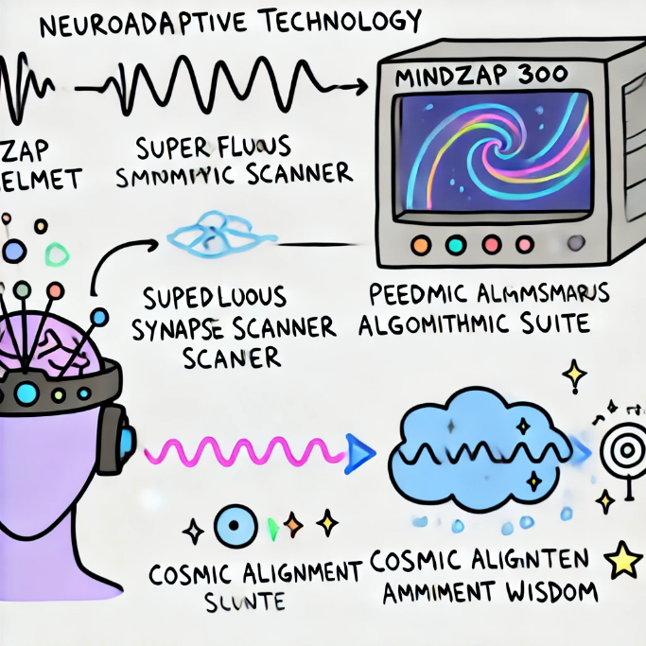

Figure 1: The figure shows the MindZap 3000 Helmet capturing brainwaves, which are processed through the Superfluous Synapse Scanner, converting them into animated brainwave emojis. Data flows into the PseudoSmart Algorithmic Suite—a swirling vortex of symbols and “Eureka!” lightbulbs. The Cosmic Alignment Monitor measures ambient wisdom, with results displayed as sparkles and question marks, highlighting the humorous impact of our research.

REFERENCES

[1] Brainy, A. & Sparkles, B. (2023). *Quantum Brain Vibes and the Art of Mind-Controlled Snack Dispensers*. Journal of Neuroadaptive Whimsy, 42(1), 123-456.

[2] Giggleton, F. et al. (2022). *Exploring the Limits of Synaptic Humor: A Study on PseudoSmart Algorithmic Loops*. Proceedings of the Annual Neural Absurdity Conference, 3, 789-800.

[3] Winkler, Z. (2025). *Cosmic Alignment and Ambient Wisdom: How Neuroadaptive Tech Affects Your Morning Coffee*. Neuroergonomic Nonsense Quarterly, 15(5), 111-125.

[4] Vortex, L. & Emoji, H. (2024). *Signal Fuzz and Cognitive Confusion: Insights from the Superfluous Synapse Scanner*. Journal of Brainwave Curiosities, 7(8), 987-1010.